**HW 2**

Ying Liu

**Exercise 1**

* 1. The correlation between X and Y is -0.17885





* 1. The coefficient is -180

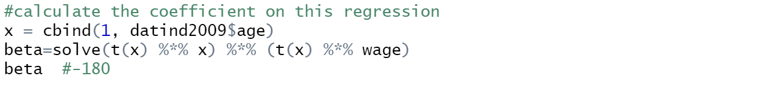



* 1. 1) Using the standard formula, the standard error of beta is 6.968652



2) Using the bootstrap with 49 and 499 replications, the standard error of beta is 6.97. The first method usually draws a sample of normal distribution. For the unknown distribution of beta, the second one can be a more reliable way.

Exercise 2

2.1 

2.2 

For the group of people with older age, wage goes up as the time goes; But for the group of people with younger age, wage almost stays constant across the year.

2.3

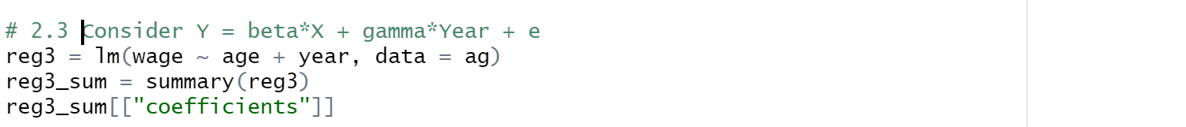

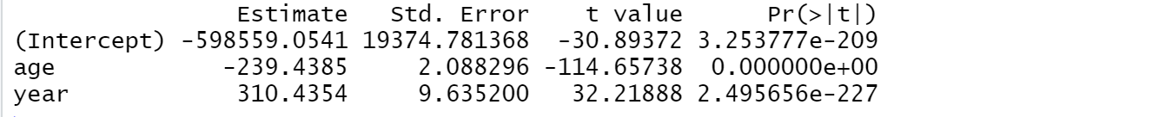

The effect of the age becomes larger after including the year.

Exercise 3



The coefficient of age is 1.0524, which is relatively small but positive, meaning that as the age grows, the person has greater probability of being employed.

3.4



The answer is no. We cannot estimate the same model including wage. Because the wage has tight relation with the age.

Exercise 4

4.2

1)Probit

文本

2)Logit

文本

3)Linear

文本

4.3 Firstly, let us see the coefficient of age, beta1. All the three models show that the age has a positive effect on the employment status. Secondly, for beta0, all the three models show that in 2005 people has pos*itive* probability of being employed. Thirdly, when we consider the impact of the year, we can see that probit and logit models show the relatively similar outputs.

Exercise 5

5.1

5.2

文本

